Task 7:

1. class Person {
var apartment: Apartment?
deinit { print("Person freed") }
}
class Apartment {
weak var tenant: Person?
deinit { print("Apartment freed") }
}
var p: Person? = Person()
var a: Apartment? = Apartment()
p?.apartment = a
a?.tenant = p
p = nil
a = nil

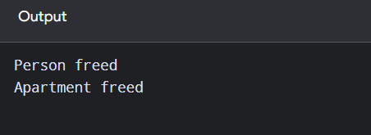

2. class Downloader {
var name: String
var onFinish: (() -> Void)?
init(name: String) {
self.name = name
}

func start() {
onFinish = { [weak self] in
if let self = self {
print("Finished \(self.name)")
}
}
}

deinit {
print("Downloader freed")
}
}

var d: Downloader? = Downloader(name: "File")
d?.start()
d = nil

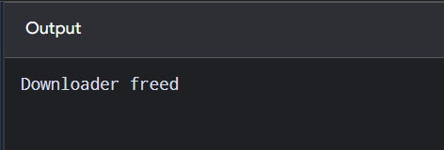

3.

